
TAMPINES MERIDIAN JUNIOR COLLEGE
JC2 PRELIMINARY EXAMINATION

CANDIDATE
NAME
CIVICS GROUP

H1 GEOGRAPHY 8834/01
Paper 1 1 September 2026 3 hours
Additional materials: 12 Page Answer Booklet
1 Insert ____________________________________________________________________________

READ THESE INSTRUCTIONS FIRST

Write your answers in the answer booklet provided. You should follow the instructions on the front cover of the answer booklet. If you need additional answer paper ask the invigilator for a continuation booklet.

Answer Question 1 in Section A.

Answer both questions in Section B.

Answer two questions in Section C.

The Insert contains all the Resources referred to in the questions.
You should make a reference to appropriate examples studied in the field or the classroom, even where the examples are not specifically requested by the question.
Diagrams and sketch maps should be drawn wherever they serve to illustrate an answer.
You are reminded of the need for good English and clear presentation in your answers.

The number of marks is given in the brackets [ ] at the end of each question or part question.

______________________________________________________________________
This document consists of 4 printed pages.
Section A
Answer all questions in this section.
Cluster 2 Fieldwork

1 | (a) | Explain whether the students’ hypothesis is suitable.  Capable of research: Clearly defined Independent variable (BCRS) [1] and dependent variable (success of increasing recycling) which can be measured via the use of questionnaire surveys of perception [1]  Unsuitable Scale: Too ambitious for 8 students in 3 hours over 2 days to cover the whole of Singapore. [1] | [3]
 | (b) | Suggest how the students could minimise two potential risks arising from undertaking the fieldwork in the locations shown in Resources 1A and 1B.  Risk of collisions and spillages: conduct survey only when seated or in a corner of the food centre. [1]+[1]  Risk of confrontations: wear uniform, explain objectives clearly and seek permission from management. [1]+[1] | [4]
 | (c) | Suggest possible issues related to research ethics for this investigation.  Suggested responses:  - Intrusion of privacy [1]+[1]  - Delay of time [1]+[1]  - Obstruction of passage [1]+[1] | [4]
 | (d) | Explain the strength(s) and limitation(s) of the survey questionnaire seen in Resource 2.  Strengths:  - Use of multiple choice Likert scale: Quick to employ [1]  - Relevant questions [1]+[1]  Limitations:  - Ambigious descriptions and lack of quantifiers. [1]+[1]  - 5-point Likert scale may result in Non-response bias [1]+[1]  - Leading Question at the end of survey. [1]+[1] | [6]
 | (e) | With reference to Resource 3, explain how the data representation can be improved.  Use of proportional symbols such as bar charts or pie charts [1].  Visually impactful as the data is proportional to the height of bars / size of sector [1] and thus can facilitate comparison at a glance [1] | [3]
 | (f) | The students concluded that the Beverage Container Return Scheme has been successful in increasing recycling in Singapore.  Evaluate the validity of their conclusion.  Evaluations should consider:  - Data analysis  - Analysis of Reliability  - Analysis of Accuracy  - Analysis of Sufficiency  Levels marked using Generic Level Descriptors for H1 Fieldwork Evaluative Question 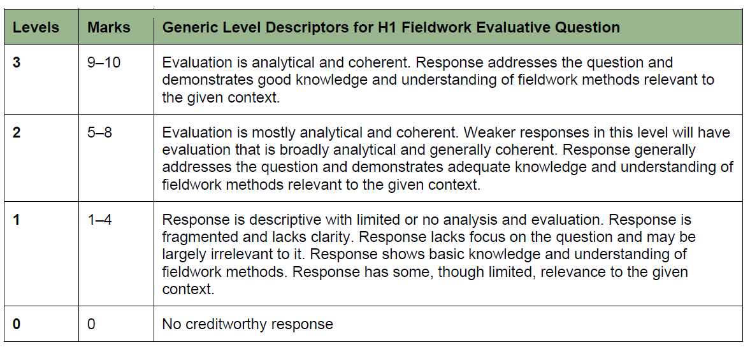 | [10]
Section B
Answer both questions from this section.

Cluster 1 Sustainable Future and Climate Change

2 | Resource 4 shows the top 10 most liveable cities baded on the Economist Intelligence Unit’s Global Liveability Index in 2026.  Resource 5 shows the map of the top 10 and bottom 10 cities based on Mercer’s Quality of Living City Ranking, 2024.  Resource 6 shows China’s Urban Sustainability Indicators compared to developed world standards in 2022.
 | (a) | Define what is meant by Urban liveability?  Urban liveability is a relative term referring to the economic, social and environmental factors which makes a place attractive (1). It’s precise meaning depends on the place, time, purpose of the assessment and on values of the assessor (1). Thus quality is not an attribute inherent in the environment but a  behaviour-related function of the interaction between individuals and their  environment (1). Credit use of egs (1) | [3]
 | (b) | Describe the distribution of urban liveability shown in Resource 5.  Very high degree of spatial concentration:  - Top 10 all from DCs (North of the Brandt Line)  - Majority of Top 10 in Europe (8/10)  - Bottom 10 concentrated in Africa (9/10) | [3]
 | (c) | Suggest reasons for the differences in rankings of the most liveable cities between Resource 4 and Resource 5.  Reasons for difference  - Time – 2 years difference between the rankings. Perceptions can change very quickly, especially after changes in government or economic recessions.  - Purpose of the assessment: this will affect the relative weighting placed on the economic, social and environmental dimensions of liveability.  - Values of the assessor: this will affect the judgement criteria of quality. What constitutes favourable living conditions vary considerably between demographic groups. Young people vs elderly. Rich vs poor.  - Methodology of the research: the results may vary due to differences in how the information on perception was derived. | [6]
 | (d) | Using Resource 6, describe China’s progress towards achieving social and environmental sustainability. | [4]
 | (e) | Explain how China’s progress towards social and environmental sustainability may impact the liveability of Chinese cities.  Improve the social dimension of liveability: illustrate with data  Improve the environmental dimension of liveability: illustrate with data - less uncollected waste and untreated sewage… make the surroundings, more pleasant  May adversely affect the economic dimension of liveability: illustrate with data- improved provision of water/waste collection could raise the cost of living in Chinese cities. Improvements in SO₂,NO_{X}, PM10 could have come from replacing fossil fuels with more costly renewable energy. This could have raised the cost of manufacturing in China and prompted firms to relocate production to other countries and adversely affect incomes/jobs in Chinese cities. | [6]

4 | Resource 7 shows the changes in average temperature for Singapore from 1990 to 2026. Resource 8 shows the circles of sustainability for Beijing and Singapore. Resource 9 shows the rooftop garden of Kampong Admiralty, a vertical retirement village in Singapore. Development of such gardens are increasingly encouraged by the government as a response to climate change.
 | (a) | Using Resource 7, describe the changes in average temperature for Singapore from 1990 to 2026.  Direction: Increase (1) gradually/continuously over time despite fluctuations (1)  Magnitude: Approx 1°C increase from 27.6 to 28.6 (1)  Rate: Spikes in 1998, 2016 and 2019 (1) | [3]
 | (b) | Suggest how the changes in temperature shown in Resource 7 may affect the liveability of Singapore.  Reduce quality of the environment:  - make the already hot weather more unbearable.  - Increased temperatures may also increase the occurrence of high rainfall that may trigger flash floods.  Reduce social dimension of liveability:  - higher temperatures may affect recreational activities such as outdoor sports and walkability.  Reduce economic dimension of liveability:  - increased temperatures may drive the need for more air conditioning that will increase the cost of electricity bills for households/businesses and thus drive up the cost of living. | [5]
 | (c) | Compare the urban sustainability performance between Beijing and Singapore shown in Resource 8.  Similarities: Economic dimension where 4 out of 7 sectors/indicators had identical values.  Differences: Overall Singapore has a much better performance in almost all other aspects.  Least difference is in economic dimension, where Beijing actually outperforms Singapore, with Beijing having all sectors at least Highly Satisfactory. Singapore has 2 /7 sectors considered only Satisfactory.  Greatest measured difference is in ecology, where Sg has all 7 sectors considered Highly Satisfactory and above whereas Beijing has only one Highly Satisfactory and all the others being Satisfactory or Critical (3 sectors).  For Politics and Culture, the 2 cities are even more different as the sectors/indicators measured are also different. | [4]
 | (d) | Suggest how development of rooftop gardens such as that shown in Resource 9 may contribute to the sustainable urban development of Singapore.  Economic vitality: Rooftop gardens may be used to grow food crops/vegetables  Social well-being: Provide recreational space  Environmental integrity: Carbon sink to mitigate climate change | [6]
 | (e) | Explain how complexes like Kampong Admiralty can contribute to the liveability of the elderly in Singapore.  Social well-being: Provide safe accommodation for the elderly, since KA will have staff to cater to the mobility and health needs of the elderly.  Psychological well-being: Provide companionship as the elderly will be living with others in their age group to share common memories and shared aspirations  Economic well-being: KA can provide subsidised / affordable housing for the elderly. By reaping economies of scale, KA can provide cheaper food and necessities for the elderly. Healthy elderly may also take on jobs at KA to provide for their fellow residents. | [4]

Section C

Answer two questions from this section.

4 | “Effective waste management is necessary for progress towards sustainable urban development.”  Discuss the statement in relation to cities in countries at various levels of development. | [13]
Possible Approaches:

Candidates could approach the question by making a judgement on whether effective waste management is necessary for progress towards sustainable urban development by illustrating how effective waste management achieves specific SDGs in all 3 dimensions of sustainability. Candidates could also argue that the adoption of more circular modes of urban metabolism facilitate achievement of the inter-generational dimension of sustainable urban development. Candidates should then counter by considering other necessary conditions for the achievement of SUD- adoption of renewable energy sources, addressing slum housing …

Candidates could also approach the question by making a judgment on whether some measures to attain SUD have a greater influence in some contexts than others through a consideration of two or more case studies. Candidates could evaluate the relative significance of the different measures in each case study and analyse the interplay between the factors.

Levels marked using Generic Level Descriptors for H1 essays
5 | “Climate change is a prime example of injustice.” Evaluate the validity of this statement. | [13]
Possible Approaches:

Candidates could approach the question by considering the injustice of climate change in relation to the causes of climate change as well as the selective nature of its impacts. Candidates could also argue that those most culpable for climate change are rarely the ones suffering the most grievious consequences.

Candidates could also approach the question by making a judgment on whether climate change is a prime example of injustice through a consideration of two or more case studies. Candidates could evaluate the relative benefits and costs of climate change in each case study and analyse the interplay between the factors.
Levels marked using Generic Level Descriptors for H1 essays

6 | Evaluate the importance of the state in responding to climate change.  Possible Approaches:  Candidates could approach the question by comparing the role of the state to that of other actors. Candidates could argue that while firms are important in innovation of mitigating and adaptation technologies, the state has the important role of regulating the adoption of such technologies, hence portraying the relationship between the various actors as necessary partnerships in responding to climate change.  Candidates could also approach the question by making a judgment on the relative importance of the state through a consideration of two or more case studies. Candidates could evaluate the relative significance of the different measures in each case study and analyse the interplay between the factors.  Levels marked using Generic Level Descriptors for H1 essays | [13]

